# Statement

You must implement Expression Evaluation System for space coordinate system <x,y,z> where x,y,z is of type real/float.

You must implement stack using STL. For driver/main function use expression, **"((A-(B+C)*(A+C/A))^A)+B''.** Lastly you must generate two tables as per **slides 53 and 69** against above said expression. Use A=<1,2,3>, B=<1.1,2.2,3.3> and C=<3.3,4.4,9.9>

Also

<a,b,c>+<x,y,z>=<a+x,b+y,c+z>,

<a,b,c>-<x,y,z>=<a-x,b-y,c-z>,

<a,b,c>/<x,y,z>=<a/x,b/y,c/z>,

<a,b,c>*<x,y,z>=<a*x,b*y,c*z>,

<a,b,c>^<x,y,z>=<a^x,b^y,c^z>.

# Solution

## Source Code

#include <iostream>

#include <conio.h>

#include <vector>

#include <math.h>

#include <string>

**using** **namespace** std**;**

template **<**class TV**>** class Node

**{**

public**:**

TV data**;**

Node **<**TV**>\***link**;**

Node **<**TV**>()**

**{**

**};**

**};**

//We are using template so that character stack and vector stack can be implemented simultaneously

template **<**class T**>** class Stack **{**

private**:**

Node**<**T**>** **\***top **=** **NULL;**

public**:**

Stack**()**

**{**

top **=** **NULL;**

**}**

**~**Stack**()**

**{**

**delete** top**;**

**}**

bool isempty**()**

**{**

**if** **(**top **==** **NULL)**

**return** **true;** **else**

**return** **false;**

**}**

void push**(**T value**)**

**{**

Node**<**T**>** **\***ptr **=** **new** Node**<**T**>();**

ptr**->**data **=** value**;**

ptr**->**link **=** top**;**

top **=** ptr**;**

**}**

T pop**()**

**{**

**if** **(**isempty**())**

cout **<<** "Stack is Empty"**;**

**else**

**{**

Node**<**T**>** **\***ptr **=** top**;**

top **=** top**->**link**;**

**return** ptr**->**data**;**

**delete(**ptr**);**

**}**

**}**

void showTop**()**

**{**

**if** **(**isempty**())**

cout **<<** "Stack is Empty"**;**

**else** **{**

**for** **(**int i **=** 0**;** i **<** 3**;** i**++)**

std**::**cout **<<** top**->**data**.**at**(**i**)** **<<** ' '**;**

**}**

**}**

T sTop**()**

**{**

**if** **(**isempty**())**

cout **<<** "Stack is Empty"**;**

**else**

**{**

**return** top**->**data**;**

**}**

**}**

void displayStack**()**

**{**

**if** **(**isempty**())**

cout **<<** "Stack is Empty\n"**;**

**else**

**{**

Node**<**T**>** **\***temp **=** top**;**

**while** **(**temp **!=** **NULL)**

**{**

cout **<<** ""**;**

**for** **(**int i **=** 0**;** i **<** 3**;** i**++)**

cout **<<** "\t" **<<** temp**->**data**.**at**(**i**);**

cout **<<** "\t|"**;**

temp **=** temp**->**link**;**

**}**

cout **<<** "\n"**;**

**}**

**}**

**};**

//operator precedence

int prec**(**char c**)**

**{**

**if** **(**c **==** '^'**)**

**return** 3**;**

**else** **if** **(**c **==** '*' **||** c **==** '/'**)**

**return** 2**;**

**else** **if** **(**c **==** '+' **||** c **==** '-'**)**

**return** 1**;**

**else**

**return** **-**1**;**

**}**

//Function to convert Infix string to Postfix string

string infixToPostfix**(**string s**)**

**{**

Stack **<**char**>** stackOfChar**;**

stackOfChar**.**push**(**'n'**);**

int l **=** s**.**length**();**

string arrangedStack**;**

**for** **(**int i **=** 0**;** i **<** l**;** i**++)**

**{**

**if** **((**s**[**i**]** **>=** 'A' **&&** s**[**i**]** **<=** 'Z'**)** **||** **(**s**[**i**]** **>=** 'A' **&&** s**[**i**]** **<=** 'Z'**))**

arrangedStack **+=** s**[**i**];**

**else** **if** **(**s**[**i**]** **==** '('**)**

stackOfChar**.**push**(**'('**);**

**else** **if** **(**s**[**i**]** **==** ')'**)**

**{**

**while** **(**stackOfChar**.**sTop**()** **!=** 'n' **&&** stackOfChar**.**sTop**()** **!=** '('**)**

**{**

char c **=** stackOfChar**.**sTop**();**

stackOfChar**.**pop**();**

arrangedStack **+=** c**;**

**}**

**if** **(**stackOfChar**.**sTop**()** **==** '('**)**

**{**

char c **=** stackOfChar**.**sTop**();**

stackOfChar**.**pop**();**

**}**

**}**

**else** **{**

**while** **(**stackOfChar**.**sTop**()** **!=** 'n' **&&** prec**(**s**[**i**])** **<=** prec**(**stackOfChar**.**sTop**()))**

**{**

char c **=** stackOfChar**.**sTop**();**

stackOfChar**.**pop**();**

arrangedStack **+=** c**;**

**}**

stackOfChar**.**push**(**s**[**i**]);**

**}**

**}**

**while** **(**stackOfChar**.**sTop**()** **!=** 'n'**)**

**{**

char c **=** stackOfChar**.**sTop**();**

stackOfChar**.**pop**();**

arrangedStack **+=** c**;**

**}**

cout **<<** "infinix expression is: "**<<** arrangedStack **<<** "\n\n"**;**

**return** arrangedStack**;**

**}**

int main**()**

**{**

int choice**,** flag **=** 1**;**

vector**<**double**>** A **=** **{** 1**,**2**,**3 **},** B **=** **{** 1.1**,**2.2**,**3.3 **},** C **=** **{** 3.3**,**4.4**,**9.9 **},** ans**{** 0**,**0**,**0 **};**

Stack **<**char**>** ch**;**

Stack **<**vector**<**double**>>** s**;**

string expression **=** "((A-(B+C)*(A+C/A))^A)+B"**;**

string postfixExpression**;**

postfixExpression **=** infixToPostfix**(**expression**);** //Conversion of Expression from Infix to Postfix

//Postfix String to char array conversion

char e**[**16**];**

**for** **(**int i **=** 0**;** i **<** **sizeof(**e**);** i**++)**

e**[**i**]** **=** postfixExpression**[**i**];**

//Postfix Array Evaluation

cout **<<** "Stack Flow:\n"**;**

**for** **(**int i **=** 0**;** i **<** 15**;** **++**i**)**

**{**

s**.**displayStack**();**

**if** **(**e**[**i**]** **==** 'A'**)**

s**.**push**(**A**);**

**else** **if** **(**e**[**i**]** **==** 'B'**)**

s**.**push**(**B**);**

**else** **if** **(**e**[**i**]** **==** 'C'**)**

s**.**push**(**C**);**

**else**

**{**

vector**<**double**>** op1 **=** s**.**pop**();**

vector**<**double**>** op2 **=** s**.**pop**();**

**switch** **(**e**[**i**])**

**{**

**case** '+'**:**

**for** **(**int i **=** 0**;** i**<**3**;** i**++)** **{**

op2**[**i**]** **=** op2**[**i**]** **+** op1**[**i**];**

**}**

s**.**push**(**op2**);**

**break;**

**case** '-'**:**

**for** **(**int i **=** 0**;** i **<** 3**;** i**++)** **{**

op2**[**i**]** **=** op2**[**i**]** **-** op1**[**i**];**

**}**

s**.**push**(**op2**);**

**break;**

**case** '*'**:**

**for** **(**int i **=** 0**;** i **<** 3**;** i**++)** **{**

op2**[**i**]** **=** op2**[**i**]** **\*** op1**[**i**];**

**}**

s**.**push**(**op2**);**

**break;**

**case** '/'**:**

**for** **(**int i **=** 0**;** i **<** 3**;** i**++)** **{**

op2**[**i**]** **=** op2**[**i**]** **/** op1**[**i**];**

**}**

s**.**push**(**op2**);**

**break;**

**case** '^'**:**

**for** **(**int i **=** 0**;** i **<** 3**;** i**++)** **{**

op2**[**i**]** **=** pow**(**op2**[**i**],** op1**[**i**]);**

**}**

s**.**push**(**op2**);**

**break;**

**}**

**}**

**}**

s**.**displayStack**();**

ans **=** s**.**sTop**();**

cout **<<** "\n\nInfix expression " **<<** expression **<<** " is: " **<<** endl**;**

cout **<<** "\nIt becomes postfix expression as " **<<** e **<<** " is: " **<<** endl**;**

cout **<<** "\nSolution is: " **<<** e **<<** " is: "**;**

**for(**int i**=**0**;**i**<**3**;**i**++)**

cout **<<** ans**[**i**]** **<<** "\t"**;**

_getch**();**

**return** 0**;**

**}**

## Output

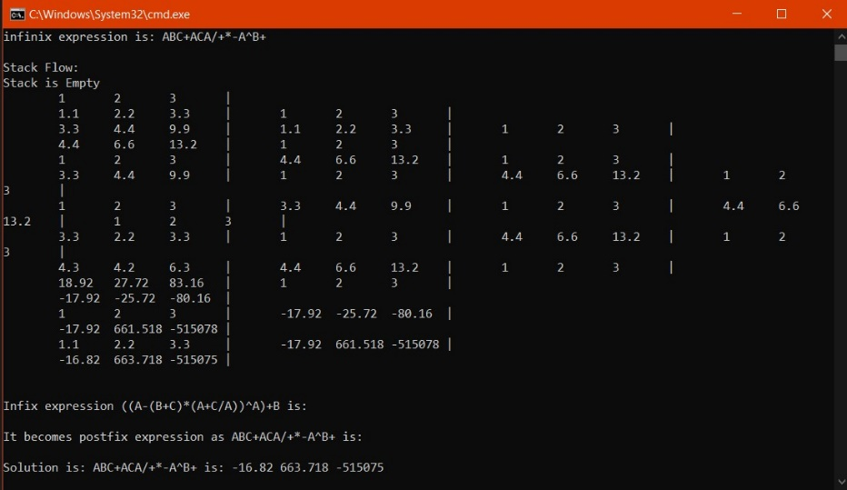

Figure : Output of the program

## Infix to Postfix:

((A-(B+C)*(A+C/A))^A)+B

|  |  |  |  |
| --- | --- | --- | --- |
| **Steps** | **Input** | **stack** | **Postfix** |
| 1 | ( | ( |  |
| 2 | ( | (( |  |
| 3 | A | (( | A |
| 4 | - | ((- | A | |
| 5 | ( | ((-( | A | |
| 6 | B | ((-( | AB | |
| 7 | + | ((-(+ | AB | |
| 8 | C | ((-(+ | ABC | |
| 9 | ) |  | ABC+ | |
| 10 | * | ((-* | ABC+ | |
| 11 | ( | ((-*( | ABC+ | |
| 12 | A | ((-*( | ABC+A | |
| 13 | + | ((-*(+ | ABC+A | |
| 14 | C | ((-*(+ | ABC+AC | |
| 15 | / | ((-*(+/ | ABC+AC | |
| 16 | A | ((-*(+/ | ABC+ACA | |
| 17 | ) |  | ABC+ACA/+ | |
| 18 | ) |  | ABC+ACA/+*- | |
| 19 | ^ | (^ | ABC+ACA/+*- | |
| 20 | A | (^ | ABC+ACA/+*-A | |
| 21 | ) |  | ABC+ACA/+*-A^ | |
| 22 | + | + | ABC+ACA/+*-A^ | |
| 23 | B | + | ABC+ACA/+*-A^B | |
| 24 | final |  | ABC+ACA/+*-A^B+ | |

## ABC+ACA/+*-A^B+

**Solution:**

|  |  |  |  |  |
| --- | --- | --- | --- | --- |
| **Input** | **Op1** | **Op2** | **value** | **stack** |
| A | -- | -- | -- | A |
| B | -- | -- | -- | A | B |
| C | -- | -- | -- | A|B|C |
| + | B | C | B+C | A | (B+C) | |
| A | -- | -- | ---- | A|(B+C)|A | |
| C | -- | -- | -- | A|(B+C)|A|C | |
| A | -- | -- | -- | A|(B+C)|A|C|A | |
| / | C | A | C/A | A|(B+C)|A|C/A | |
| + | A | C/A | A+C/A | A|(B+C)|(A+C/A) | |
| * | B+C | A+C/A | (B+C)*(A+C/A) | A|((B+C)*(A+C/A)) | |
| - | A | (B+C)*(A+C/A) | A-(B+C)*(A+C/A) | A-(B+C)*(A+C/A) | |
| A | -- | -- | -- | A-(B+C)*(A+C/A)|A | |
| ^ | A | A-(B+C)*(A+C/A) | A^(A-(B+C)*(A+C/A)) | (A-(B+C)*(A+C/A))^A | |
| B | -- | -- | -- | ((A-(B+C)*(A+C/A))^A)|B | |
| + | B | A^ A-(B+C)*(A+C/A) | B+(A^(A-(B+C)*(A+C/A))) | ((A-(B+C)*(A+C/A))^A)+B | |

|  |  |  |  |  |
| --- | --- | --- | --- | --- |
| **Input** | **Op1** | **Op2** | **value** | **stack** |
| 1,2,3 | -- | -- | -- | 1,2,3 |
| 1.1,2.2,3.3 | -- | -- | -- | 1,2,3 |1.1,2.2,3.3 |
| 3.3,4.4,9.9 | -- | -- | -- | 1,2,3 |1.1,2.2,3.3|3.3,4.4,9.9 |
| + | 1.1,2.2,3.3 | 3.3,4.4,9.9 | 4.4,6.6,13.2 | 1,2,3 | 4.4,6.6,13.2 | |
| 1,2,3 | -- | -- | ---- | 1,2,3 | 4.4,6.6,13.2|1,2,3 | |
| 3.3,4.4,9.9 | -- | -- | -- | 1,2,3 | 4.4,6.6,13.2|1,2,3|3.3,4.4,9.9 | |
| 1,2,3 | -- | -- | -- | 1,2,3 | 4.4,6.6,13.2|1,2,3|3.3,4.4,9.9|1,2,3 | |
| / | 3.3,4.4,9.9 | 1,2,3 | 3.3,2.2,3.3 | 1,2,3 | 4.4,6.6,13.2|1,2,3|3.3,2.2,3.3 | |
| + | 1,2,3 | 3.3,2.2,3.3 | 4.3,4.2,6.3 | 1,2,3 | 4.4,6.6,13.2|4.3,4.2,6.3 | |
| * | 4.4,6.6,13.2 | 4.3,4.2,6.3 | 18.92,27.72,83.16 | 1,2,3 |18.92,27.72,83.16 | |
| - | 1,2,3 | 18.92,27.72,83.16 | -17.92,-25.72,-80.16 | -17.92,-25.72,-80.16 | |
| 1,2,3 | -- | -- | -- | -17.92,-25.72,-80.16|1,2,3 | |
| ^ | -17.92,-25.72,-80.16 | 1,2,3 | -17.92,661.518,-515078 | -17.92,661.518,-515078 | |
| 1.1,2.2,3.3 | -- | -- | -- | -17.92,661.518,-515078|1.1,2.2,3.3 | |
| + | 1.1,2.2,3.3 | 17.92,661.518,-515078 | -16.82,663.718,-515075 | -16.82,663.718,-515075 | |